We have automated the workflow where a user can search for a file in Google Drive, summarize it using LLM model and then save the summary in a Google Doc.

The workflow steps are outlined below:

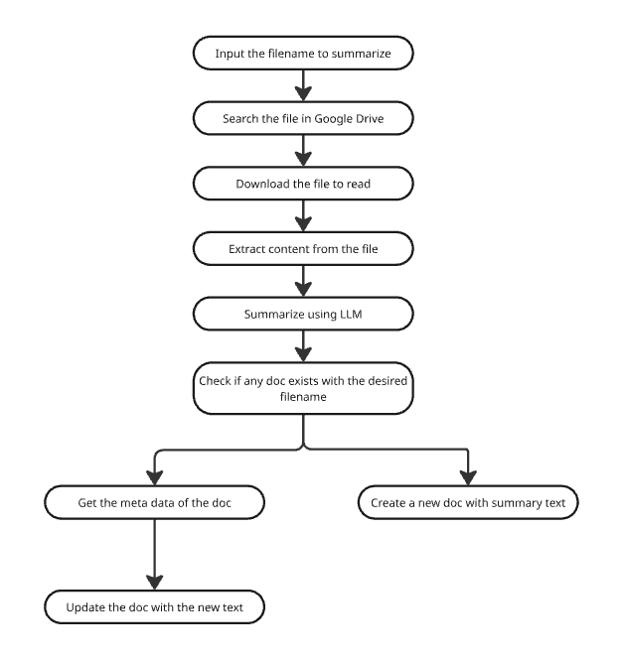

**Prerequisites:**

* Google Console Credentials: Client ID and Client Secret
* Google Drive API enabled
* Google Docs API enabled
* Mistral API Key

**Step-by-Step Process**

**Step-1: Create a new Workflow**

You need to select **Create Workflow** from the top left of the canvas.

A blank canvas will open.

**Step-2: Select the first Node to input the filename**

When you click on the **+** icon on canvas, n8n will prompt you with **What triggers this workflow?** At the top of the dialog, there is a search bar where you can type any keyword to filter the available options.

Here, you need to search for 'edit' and select **Edit Fields (Set)** from the list.

The following screen will open:

You'll see the Parameters tab is active by default, with several configuration options:

* Mode: Manual Mapping (the default selection).
* Fields to Set: Click on **Add Field** button.

Once you click **Add Field**, a new field row will appear.

* Field Name: Type **query**
* Field Type: Set to **String** (from dropdown)
* Field Value: Input the filename to search (Example: Cognitive Architectures for Language Agents.pdf) in Google Drive.

Keep the other parameters as default.

Now, if you click on **Back to canvas** from the top left, you will see that two icons have been added to the canvas



**Step-3: Search file in Google Drive**

If you click on the **+** icon next to **Edit Fields**, n8n will prompt you with **What happens next?**. Type 'google drive' in the search bar, and you will see 2 options. Select **Google Drive** and it will navigate you to a list of associated actions.

Select **Search files and folders**.

The following configuration window will open. If you already have credential for Google Drive, select it from the drop-down, otherwise select **Create new credential**.

New window to create credentials will open:

If you don’t have Client ID and Client Secret in Google Cloud and Google Drive is not enabled in the services, then go to <https://console.cloud.google.com/>. Following window will appear.

* Click on **Select a project**.

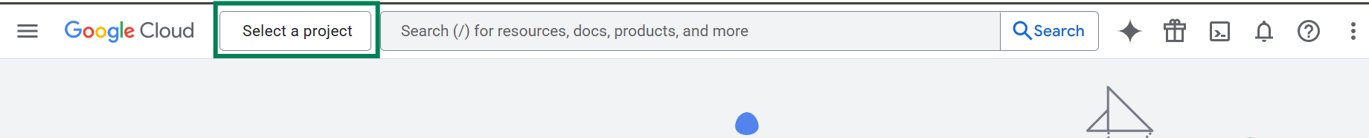

* Click on **New Project**

* Fill in the required information and click on **Create** button.

A billing account will be required to proceed with the services.

* Check whether the correct project is selected or not.

* Select **API & Services**.

* Go to **Enabled APIs & Services**.

* Search ‘google drive’. Select **Google Drive API** from the list.

* Check if Google Drive API is enabled or not.

* If API is disabled, click on **Enable** button to enable it.

* Go to **Credentials** now.

* Click on **Create Credentials**.

* Select **OAuth client ID** from the list.

* Fill in the information as follows:

* Copy following URL from N8N window and add it here. Click on **Save** button.

* Once the credentials are created store it in a secure location. You can’t retrieve the **Client Secret** later from the console.

You have successfully created the credential for Google Drive. Now, go to N8N again and fill in the credential information.

Click on **Sign in with Google**. Select the google account.

Click **Continue**.

Check **Select all** and click on **Continue**.

If the connectivity is established, you will see following prompt.

You will now see **Account connected** on the top of the credential screen.

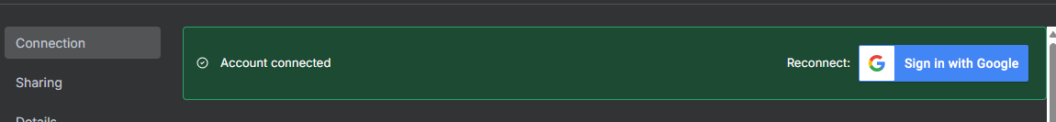

Click on cross button to exit the credential screen and get back to the **Search files and folders** window.

Follow these steps for the configuration:

* Resource: Select **File/Folder**
* Operation: Select **Search**
* Search Method: Select **Search File/Folder Name**
* Search Query: Enter the search term. You can type *'{{ $json.query }}'* manually, or if the previous step is executed, you will see it in the input panel on the left. You can drag the field and put it in this field, which pulls the value from the previous step.
* Return All: Keep disabled
* Limit: Set to '1' as we only want the first matching result
* Drive: Select **My Drive**
* Folder: Specify the folder from dropdown where you want to search
* Options: Under the Fields section, you can select what information to return. **Name** and **ID** are selected here.

You can add more filters by clicking **Add Filter**.

You can click on **Execute step** if you want to check the output from this step. If this is executed, you can use this output as input for the next step to execute and test that as well.

You can rename this step with a meaningful title(as example: Search file in Google Drive) to make it easier to understand the purpose of the step.

If you want to know more details about a particular node, click on **Docs**.

Click on **Back to canvas** to exit from this window.

Click on **Save** or press **Ctrl+S** after adding any new component or making changes, otherwise it will not be saved automatically.



**Step-4: Download file to read the full content**

Click on the + button to add next step.

For the next node, select **Download file** under Google Drive.

Following configuration panel will appear:

You need to set up the following parameters:

* Credential to connect with: Select your **Google Drive account** from the dropdown (same as the previous step).
* Resource: Select **File**
* Operation: Select **Download**
* File ID: Enter *'{{ $json.id }}'* in this field. You can either type this manually or drag the 'id' field from the input panel on the left (which shows the output from the previous **Search files and folders** step). This pulls the file ID from the search results.

Under **Options**, click on **Add option** and select **Put Output File in Field** from the dropdown. Set this to 'data' (this is where the downloaded file content will be stored).

The input panel on the left shows the available data from the previous step, including the file ID that you can reference. Once configured, you can click **Execute step** to test the file download functionality.

**Step-5: Extract content from downloaded file**

In the next step, type “extract” and select **Extract from File** and from the available options.

The configuration panel will open:

Select **Extract from PDF** as the operation, and the 'Input Binary Field' will contain 'data' as the default.

**Step-6: Summarize document using LLM**

In the next step, select **Basic LLM Chain** from the trigger list.

The configuration panel will open:

The key settings are:

* Source for Prompt (User Message): Define below
* Prompt (User Message): You can add instructions here to guide the model to respond in your preferred way. Add the text field from the previous node's JSON output and append it to the summarization instruction.
* Require Specific Output Format: Keep disabled.
* Enable Fallback Model: Keep disabled.
* Chat Messages (if Using a Chat Model): You can configure one or more message types. Here, 2 types have been used for generating better output.

Type-1:

* + Type Name or ID: AI
  + Message: Share an example of your preferred output or generated summary text.

Type-2:

* + Type Name or ID: System
  + Message: Input the system prompt message to instruct the model about its role and responsibilities.

Now, click on the plus icon to add the model.

Search with the keyword “mistral” and select **Mistral Cloud Chat Model** from the list.

Following window will open:

The key settings are:

* Credential to connect with: If you already have Mistral Cloud account, select it from the dropdown. Otherwise, select **Create new credentials**.

To get the API key, go to <https://mistral.ai/> . If you don’t have any Mistral account, create a new account and sign in. After signing in, click on **API Keys** from the left-side menu.

Click on **Create new key**.

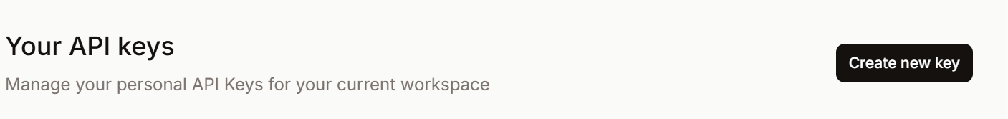

Write a name and click on **Create new key**. Don’t select any expiration date if expiration not required.

Once API key is created, copy the key and store it in a secure place.

Use this API key to create the credentials for Mistral Cloud Account in n8n.

Once credential is created, go back to the **Mistral Cloud Chat Model** configuration window and proceed with rest configuration.

* Model: Choose your preferred model (here, mistral-8b-latest has been selected) from the dropdown.
* Options: It can be left empty or can be configured if you want to fine-tune generation parameters.

**Step-7: Check whether another file exists with the same name**

For next step, again select **Search files and folders** from the list.

Key settings are:

* Credential to connect with: Select your **Google Drive account** from the dropdown.
* Resource: Choose **File/Folder**.
* Operation: Select **Search**.
* Search Method: Choose **Search File/Folder Name**.
* Search Query:

Dynamically generate the search string by taking the filename from the previous node, removing .pdf, and prefixing it with "Summary of".

*“Summary of {{ $("Download file for reading the content").item.json.name.replace(".pdf","") }} “*

* Return All: Keep disabled.
* Limit: Set to 1 (returns only the first matching file).
* Filter:
  + Drive: Select **My Drive** from the list.
  + Folder: Select the folder from the list (restricts search to this specific folder).

**Step-8: Routing to relevant journey using conditional statement**

In the next step, we will check if there is any doc file with the same name. If yes, we will replace the content with the updated one. Otherwise, we will create a new doc.

From the following screenshot, we can see 2 different routes based on the doc availability.

Add node “If” from the action list and following window will appear:

Key settings

Conditions:

* Add condition: Check if the id field exists from the Check if a doc with same name exists node output.
* Operator: Select **exists**

**Step-9: Create a new file if the conditional node returns False**

The **If** node has 2 Boolean outputs – True and False. For the False node, select **Create file from text** for the next step.

Following window will open:

The key settings are:

* Credential to connect with: Select your **Google Drive account** from the dropdown.
* Resource: Choose **File**.
* Operation: Select **Create From Text**.
* File Content: Pulls the summary output generated by the **Basic LLM Chain** node.  
  *{{ $("Basic LLM Chain1").item.json.text }}*
* File Name: Dynamically names the new file as “Summary of [original filename without .pdf]”.  
  *Summary of {{ $("Download file for reading the content").item.json.name.replace(".pdf","") }}*
* Parent Drive: Select **My Drive**
* Parent Folder: Select the target folder.
* Options:

Convert to Google Document: Enabled. It ensures the created file is a Google Doc rather than a plain text file. Please ensure **Google Docs API** is enabled (follow the similar steps like Google Drive).

If Google Doc credential is working okay, you will see following screen.

**Step-10: Get meta data of the file if conditional node returns true**

For the True node, select **Get a document** as the next node.

Now, complete the configuration as follows:

Key settings are:

* Credential to connect with: Select your **Google Docs account** from the dropdown.
* Resource: Choose **Document**.
* Operation: Select **Get**.
* Doc ID or URL: Dynamically retrieves the document ID from the **Check if a doc with same name exists** step.

*{{ $json.id }}*

* Simplify: Keep disabled.

**Step-11: Replace the content of the existing document with the new content**

In the next step, select **Update a document**.

Following window will appear:

Key settings are:

* Credential to connect with: Select your **Google Docs account**.
* Resource: Set to **Document**
* Operation: Set to **Update**
* Doc ID or URL: Enter the document identifier using *{{ $('Check if a doc with same name exists').item.json.id }}* to reference the document ID from the previous step.
* Actions Configuration:
  + Object: Set to 'Text'
  + Action: Select 'Find and Replace Text'
  + Old Text: The entire text that exists in the document needs to be selected. Enter the text pattern to find, such as {{ $json.body.content[1].paragraph.elements[0].textRun.content }}. You can easily drag it from input section.  
      
    A screenshot of a computer

    AI-generated content may be incorrect.
  + New Text: Enter the replacement text, such as {{ $('Basic LLM Chain').item.json.text }} to insert the AI-generated summary
  + Match Case: Toggle this on or off based on whether you want case-sensitive matching

Rest of the fields shoould be kept unchanged.

**Execution:**

Now, if you click any of these, the complete workflow will be executed.

If you click on any particular node, you can see the input and output for that node like following:

